**Proceedings of the ASME 2014 International Mechanical Engineering Congress & Exposition**

**IMECE2014**

IMECE2014-36514

TOWARD AN AUTOMATED MODEL-BASED GEOMETRIC METHOD OF

**REPRESENTING FUNCTION FAILURE PROPAGATION ACROSS UNCOUPLED**

**SYSTEMS**

|  |  |
| --- | --- |
| Isaac J. Ramp  Graduate Research Assistant  Department of Mechanical Engineering  Colorado School of Mines, Golden, CO  Email: iramp@mymail.mines.edu | Douglas L. Van Bossuyt*  Assistant Professor  Department of Mechanical Engineering  Colorado School of Mines, Golden, CO  Email: dvanboss@mines.edu |

Abstract

*The complex engineered systems being designed today must rapidly and accurately be developed to satisfy customer needs while accomplishing required functions with a minimum number of failures. Failure analysis in the conceptual stage of design has expanded in recent years to account for failures in functional modeling. However, function failure propagation across normally uncoupled functions and subsystems has not been fully addressed. A functional model-based geometric method of predicting and mitigating functional failure propagation across systems, which are uncoupled during nominal use cases, is presented. Geometric relationships between uncoupled functions are established to serve as failure propagation flow paths. Mitigation options are developed based upon the geometric relationships and a path toward physical functional layout is provided to limit failure propagation across uncoupled subsystems. The model-based geometric method of predicting and mitigating functional failure propagation across uncoupled engineered systems guides designers toward improved protection and isolation of cross-subsystem failure propagation.*

1. INTRODUCTION

The complex system designs being created today must meet the required functions desired with a minimal number of failures. One useful method of analyzing failures within in a system largely depends on creating a functional failure model containing failure flows of each function. However, little progress has been made on developing an automated, repeatable method of analyzing irregular or uncoupled failure flows. Irregular failure flows are flows that do not follow along the same flow paths of the functional flow design model. These flows create cross-subsystems failures and can cause the propagation of failure throughout a complex system in ways that would not be predicted with currently available failure prediction tools.

The purpose of this paper is to provide a foundation for functional model-based geometric methods to predict and mitigate the functional failure across uncoupled functions and subsystems. The method developed in this paper is used to analyze some of the events that led to the Deep Water Horizon disaster to test its validity. This geometric method of mitigating irregular functional failure flows guides designers to improved systems of lower risk of failure propagation.

2 Specific Contributions

Existing methodologies to predict and analyze failure flow paths in complex systems often ignore irregular failure flows across uncoupled functions, require laborious manual examination of potential failure paths, or use generic estimations rather than detailed, automated analysis of potential irregular flow paths. Thus, modeling and accounting for risk and failure of uncoupled system failure and irregular flow failure is largely unaddressed. This is due to a lack of an efficient and accurate way to model irregular and uncoupled failure flows.

This paper aims to create a basis for a geometric method that models uncoupled and irregular flows. The methodology presented will allow for more comprehensive automated risk and failure analysis in the early phases of design. The methodology allows for engineers to detect potential uncoupled and irregular failure flows, and provides suggestions for mitigation of uncoupled and irregular failure flows that previously would likely not have been identified. The methodology will also provide a base for a possible automated system to be created to more efficiently use the geometric model presented.

3 BACKGROUND

There are several topic areas relevant to the functional model-based geometric method of predicting and mitigating functional failure propagation across uncoupled functions. This section reviews pertinent information in complex system design; functional modeling; advanced functional failure propagation methods such as function failure identification and propagation, and the function failure design method; and probabilistic risk assessment. The method developed in this paper builds upon key portions of each of the previously mentioned topic areas.

**3.1 Complex System Design**

Complex system design is a methodology that is used to design systems of high complexity such as aircraft, spacecraft, oil drilling platforms, and other systems of similar complexity. Complex system design involves several steps and sub-steps. One of these steps is accounting for failures or the reliability within the system design [1]. The methods used for analyzing system reliability use specific component and configuration information to predict the probability of failure occurring within the component or configuration. Currently this process is commonly practiced in complex system design. Although predicting of one component or configuration’s effect on surrounding components and systems has been under addressed.

**3.2 Functional Modeling**

Functional modeling is a system representation that is often used during complex system design. The functional model contains key functions that the design must accomplish, and connects the functions using a block diagram and flow patterns [2]. There are several ideologies on the naming of the functions and flows being used to complete the functional modeling step of the design process [3, 4, 5]. Therefore, much of the recent research into functional modeling has consisted of providing clear definitions for these sub functions and flows. The current Functional Basis was developed by Hirtz et al [6] to avoid the usage of designer-specific flows and function labels. By following the flows through the sub functions, the functionality of the device is developed.

Functional models have been used more recently to model failure propagation within a system. Functional modeling of the failures that can occur and propagate through a system has great advantages for determining the effectiveness of a system. However, the functional modeling of failures across uncoupled systems has been largely unaddressed. This area of functional failure modeling has become increasingly important with complex systems with large numbers of sub functions. Providing a geometric relationship, while using the flow classes introduced by Stone and Wood [1], between the uncoupled functions will provide paths for the failure propagation and a more accurate description of the effectiveness of a complex system.

**3.3 FFIP: Function Failure Identification Propagation**

Function Failure Identification Propagation (FFIP) is a framework used during the design stage for analyzing failures based on mapping the paths between components, functions, and nominal and off-nominal behavior [2,7]. It is a tool used to define failure paths and propagations through a complex system as well as the inherent risks that are associated with the failures.

FFIP, however, does not rely on historical databases to generate their data. It uses a simulation method that determines failure propagations and risks associated with them providing a basis for analyzing component failures [2]. It creates the ability to understand the effects of function failure propagation based on their flow behavior.

An outline of the five basic steps in FFIP analysis [2, 4] is presented below:

1. Create functional model representation of the systems
2. Create configuration flow graph of generalized components
3. Compile generalized component behavioral models into a system model
4. Create a function failure logic reasoner to evaluate function health
5. Apply critical fault simulations to the system model to identify function failures and the propagation of failure in the system

The framework’s objective is to create a relationship between failure events and the state of the functional elements to provide the designer with risk information. This methodology is also useful in the mapping of irregular or uncoupled flows. It will be the basis for the mapping method used in the case study in this paper.

**3.4 Function Failure Design Method (FFDM)**

The Function Failure Design Method is a mathematical relationship between product function and failure modes [8]. FFDM presented by Stock, Stone, and Tumer in 2003 [9] is a methodology that streamlines failure analysis and the design process. FFDM links product functions to likely failure modes thus reducing the need of the designer to have a large intellectual base of failure of knowledge. It is an archival method that uses historical knowledge and creates functional representations of each failed component in matrix form. [10]. The FFDM procedure as presented in a paper by Stock et al (2005) is shown in Figure 1.

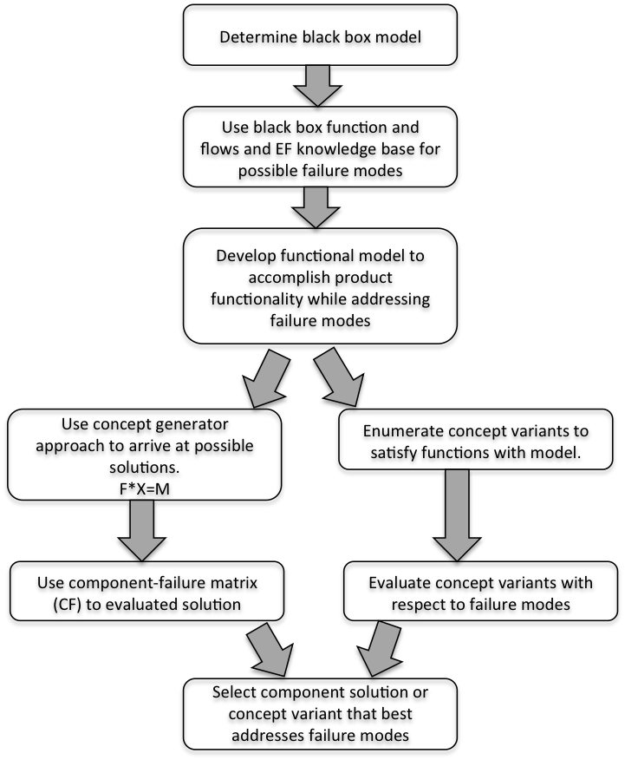

Figure 1: Function Failure Design Method

The FFDM method relies on a knowledge database created from previous product research and design. The work of Roberts et. al. [11] and Stone et. al. [12] contributes to the split in the methodology of the FFDM process. Both rely on matrix manipulation to create function failure matrices to create a solution addressing the component or function failure modes with a system.

FFDM reduces the user’s workload due to its use of archived failure knowledge bases [12]. The archival of previous knowledge of failure modes of systems and components is important in the work associated with the understanding and mitigating of irregular and uncoupled failure flow patterns.

**3.5 Probabilistic Risk Assessment (PRA)**

Probabilistic Risk Assessment (PRA) is a methodology that is often used to evaluate the risks associated with a complex system design. PRA is used to develop information that identifies a risk within a complex system, its severity, and the likelihood of the risk actually occurring.

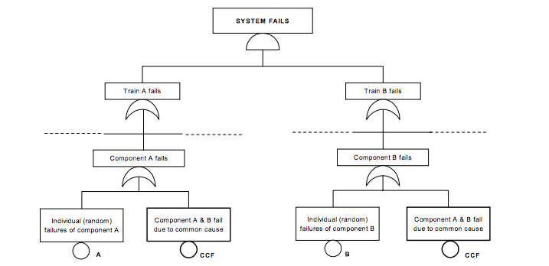One class of risk that is analyzed in PRA is common cause failures within a system. Common cause failure is where a single function or component failure affects the operation of multiple other functions or components of a complex system. This information is obtained through the usage of fault tree analysis. A common cause failure tree analysis is show in Figure 2.

Figure 2: Common Cause Failure Tree from Vrbanić, et al. [13]

There are several existing methodologies used to develop a PRA risk information including Failure Modes and Effects Analysis (FMEA). The more complex a PRA model becomes, the more detailed information and analyses are required, which limits the applicability of the PRA model during conceptual design [14, 15]. Therefore, research has been completed into linking product function to failure and then to early risk assessments [16, 12, 17].

Currently PRA is used within complex system design to analyze inherent risks of certain functions and parts within the system. However, it has not been used to predict functional failure across uncoupled systems or irregular failure flows within the design. The functional model-based geometric method of predicting and mitigating functional failure propagation across uncoupled systems presented in the methodology section of this paper offers a solution to easily analyze the functional failure across uncoupled systems or irregular failure flow problems.

4 Methodology

The goal of this research is to develop a method of modeling uncoupled function failure flow propagation, and develop functional and geometric uncoupled failure propagation mitigation strategies. To accomplish this, relational databases of function failure flows that are transmittable between uncouple functions and the impact of failure flows on otherwise nominal functions is necessary. A multi-step process is used to prepare the necessary information and use an algorithm to determine function failure flow propagation across uncoupled systems. The output provides 1) identification of uncouple function failure flow propagation paths; 2) probability of failure propagation along each uncoupled function failure flow propagation path; 3) geometric placement of functional groups that minimizes probability of system failure; and 4) placement of failure flow mitigation functions.

**Step 1: Develop Functional Model for Nominal Operations**

A functional model must be developed of the system of interest and its associated subsystems. Customer and technical requirements and other manufacturer information can provide necessary information to construct a functional model for a new product. Existing products can be functionally broken down through product or plant dissection to better understand the product’s functional model.

**Step 2: Define Failure Flow Exports**

Failure flow exports are identified from a database of exportable failure flows. A partial database example is shown in Annex A. The database example was developed as part of the case study found in Section 5 of this paper. The types of flow created are based on previous research done by Jenson et. al. [2]. The information was gathered by examining potential failure modes for all functional blocks defined in the functional basis function set. The failure modes associated with the case study were developed from analyzing the events that led to the loss of the Deepwater Horizon offshore drilling rig. Each failure mode was examined to determine what spurious functional basis flow state could occur. A practitioner using this method would tailor a similar database to the needs of the complex system under analysis. Thus for each function, a corresponding set of potential functional failure flows is provided.

**Step 3: Identifying Failure Flow Imports**

Failure flow imports are identified from a relational database of importable failure flows. An example database is shown in Annex A. The example database was derived as part of the case study for this paper and used previous research on failure state logic by Jensen et al [2]. Examining the effects of previous function failure modes on subsequent functions provides the failure flow imports of each function block. For each failure flow imported, a failure flow export of several types may be created causing a propagation of failure throughout a functional model.

**Step 4: Identifying Imported Failure Flow Effects on Otherwise Nominal Functions**

The impacts of failure flows on each function of the model are based on the parameters and features of the functions. Based on design and functionality of each function, a ranking system can be created. The lower the ranking, the less effect the failure flow has on the function, i.e. natural gas released around a storage unit for natural gas. The higher the ranking, the greater risk associated with a function if the failure flow reaches it, i.e. natural gas released around exhaust fumes. From the rankings, probability of how likely each function is to fail due to a failure flow can be derived.

**Step 5: Develop a Geometric Relationship Between Uncoupled Functions**

In complex systems, certain failure flows will propagate across uncoupled functions. Therefore to appropriately model these situations, a geometric relationship needs to be defined. This relationship is based on the location of both functional systems and the physical properties of the failure. Most of the information needed to create a geometric relationship is already defined in the design process. A geometric relationship is dependent on the distance between two functions and the angles between the two components. By deriving a geometric relationship between the uncoupled functions, a probability can be created to demonstrate the likelihood of uncoupled failure occurring.

**Step 6: Develop Geometric Arrangement to Mitigate Risk**

The probability of an uncoupled failure occurring can be used as a benchmark in the physical arrangement of the complex system. If the probability of a failure occurring due to a failure flow between uncoupled functions is too high, a rearrangement of the system can be made in order to mitigate the risk between uncoupled functions. Using the geometric relationship and derived probability, changes to the arrangement of a system can be made. The goal of rearranging the components and functions of a complex design is to lower the risk involved with the previous arrangement creating a lower risk of irregular or uncoupled failure within a system.

5 Case Study

This section applied the geometric method to the events that occurred on the Deepwater Horizon in April 2010. Due to a cement system failure at the bottom of the drilling unit, a natural gas bubble rose rapidly through the pipe causing a blowout on the deck of the rig [18]. The blowout preventer also failed, allowing an excess of natural gas to escape and collect above the generators on deck. The natural gas reacted with the exhaust from the generators, causing an explosion and subsequent fire that ended with the sinking of the Deepwater Horizon [19]. By applying the method presented in this paper to an idealized case study based on the events of the Deepwater Horizon, a probability for the events that occurred will be derived as well as possible solutions to mitigate disasters like the Deepwater Horizon experienced.

**5.1 Step 1: Functional Model**

The focus of the case study for this research is on the failure of the blowout preventer and how it affected uncoupled processes. Figure 3 below shows a simplified functional model of the blowout preventer and engine systems on the Deepwater Horizon.

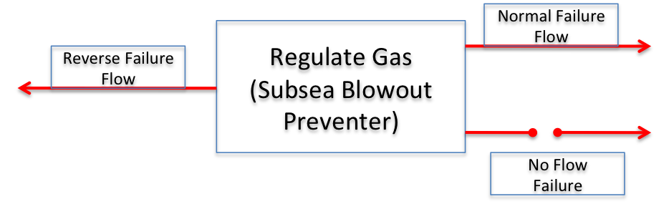**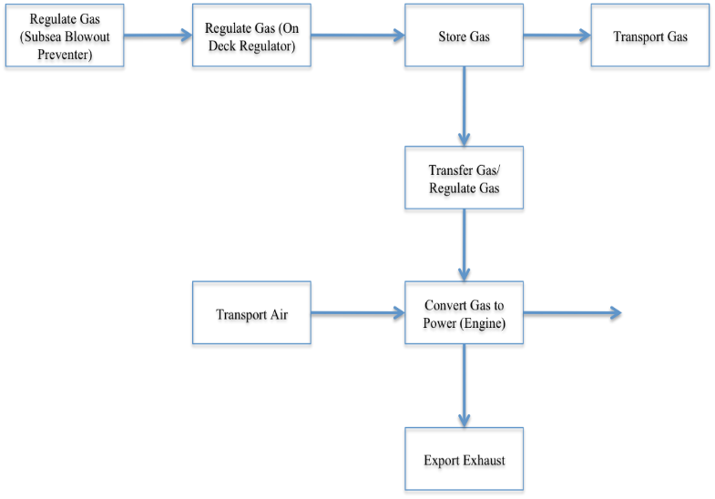5.2 Step 2: Failed Function Flows**

Figure 4: Failure Flow Exports From Subsea Blowout Preventer

Figure 3: Simplified Functional Model of the Deepwater Horizon

Due to the failure of the blowout preventer, the failure propagated into several other systems and operations on the Deepwater Horizon. Identifying each functions failure flow exports and imports leads to a propagation of failure originating at the blowout preventer. Figure 4 shows the possible failure exports with the failed function of the subsea blowout preventer.

One function may have several failure flows being exported. Normal failure flow exports are failures that propagate forward or normal to the failed function. Reverse failure flows are flows that occur when the failed component exports a failure flow backwards or against the flow of the functional model. The no flow failure occurs when a failure in a component causes the desired function flow export to be restricted or eliminated.

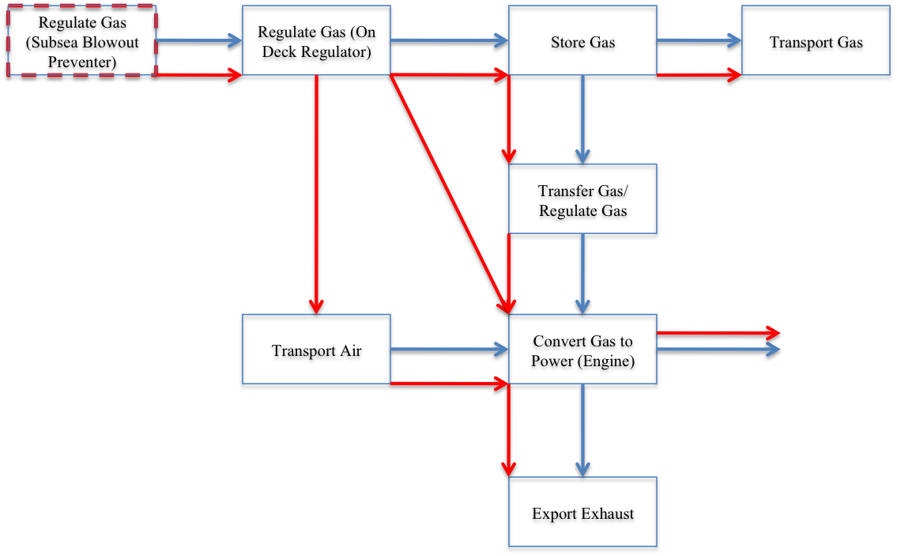For the subsea blowout preventer being analyzed in this case study, the only types of failure flow being analyzed are the normal failure flows. The possible normal failure flow exports from the subsea blowout preventer as well as a database of the failure imports and exports for each function examined in this case study can be found in Annex A. The natural gas normal failure flow export from the subsea blowout preventer is examined in this study.

Figure 5: Failed Flow Model of Uncoupled Functions. Failed flow paths shown in red. Nominal flow paths shown in blue.

**5.3 Step 3: Function Acceptance of Failed Flows**

The natural gas export from the failed regulate gas function associated with the subsea blowout preventer is the failed flow analyzed in this study. The failure flow export affects several other functions and propagates throughout the system as shown in Figure 5.

The purpose of the method presented in this paper is to analyze flows that do not obey standard failure flow procedures, i.e. ones that do not flow along the function flow pathways. The natural gas flow analyzed for the case presented in this paper is the failure flow from the regulate gas (on deck regulator) function to the transport air (air intake) function. This flow is shown in Figure 6.

Each function that imports the natural gas failed function will have an inherent risk probability associated with accepting the failure import.

The probabilities for the case study were created through expert engineering analysis. By analyzing each function’s ability to import or export failure flows, the probabilities were derived. Looking at characteristics of the failure flow and how each will react with the components in the functional model, lead to the risk probabilities associated with the flow. For instance, if a failure flow is more likely to cause a component or function to fail than it will have a high probability associated with it.

An example list of the risk probabilities coupled with the natural gas failure flow used in the case study can be found in Annex B. The high-risk probability associated with the air intake system is due to the properties of physical properties of the methane gas failure flow. The risk associated with the flow shown in Figure 6 is quite large and is a major part of the causes of the events on the Deepwater Horizon. Therefore the next step would be to rearrange the system to lower the risk probability 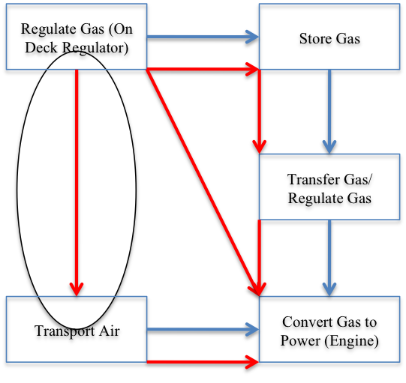shown in Annex B.

Figure 6: Failure Flow Analyzed

**5.4 Step 4: Geometric Bounding**

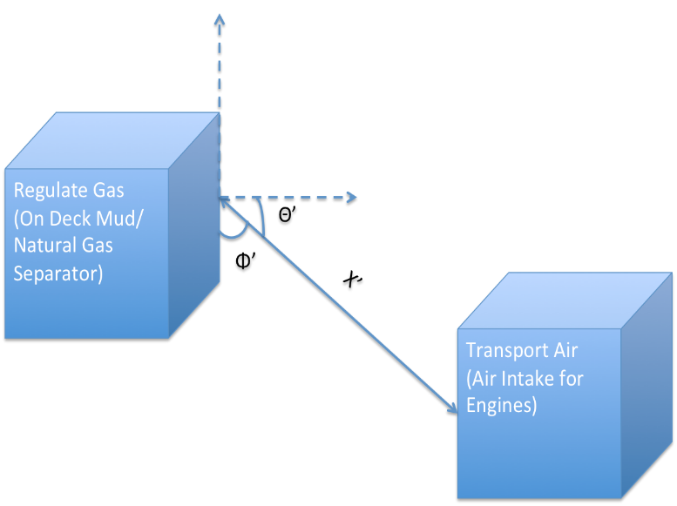 The flow between the regulate gas and convert gas functions has certain geometric bounding associated with it due to their physical arrangement. To simplify the case, an idealized geometric arrangement was considered. The geometric bounding between the two components (on deck regulator and engines/generators) is directly dependent on the distance between the two, as well as the angles to the normal between the components. Figure 7 shows the idealized arrangement between the two components of the complex design system.

Figure 8: New Geometric Arrangement

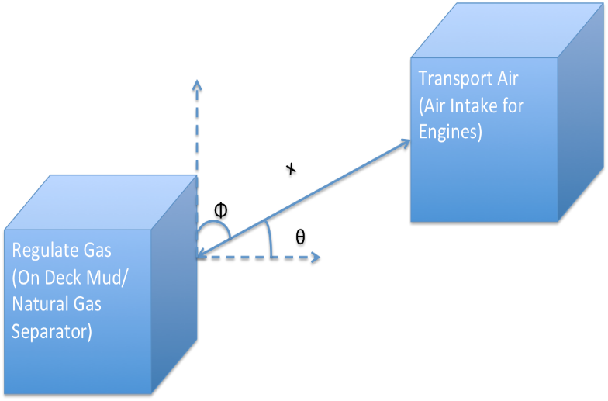

Figure 7: Geometric Relationship

**5.5 Step 5: Function Failure Data**

Another factor used in this method of analysis is the characteristics of the failure function and flow. For the Deep Water Horizon case study these aspects would be the characteristics associated with natural gas. The gas spread quickly and created a cloud that eventually reaching the engine room. The physical properties of methane gas needed for the geometric method are shown in Table 1.

**Table 1: Properties of Methane (Natural) Gas**

|  |  |  |
| --- | --- | --- |
| **Properties** |  | **Units** |
| Molecular Weight | 16.044 |  |
| Specific Gravity | 0.544 |  |
| Density | 0.717 | kg/m3 |
| Specific Heat | 2260 | J/kg*K |
| Heat of Combustion | 5327 | kJ/kg |
| Flammable | Yes | |

Since the density of air is greater than that of methane gas, methane rises quickly in air. It also dissipates relatively quickly in air.

6 Case Study Results

Using the physical properties associated with methane (natural) gas and the geometric bounds placed on the system of components, a new arrangement can be created to mitigate the risk created by the natural gas failed flow. Figure 8 displays the new arrangement.

In the instance of the natural gas release and the design of the Deepwater Horizon, Figure 8 displays one possible solution to the irregular flow pattern seen in Figure 6. This arrangement is based on the density property of natural gas being smaller than that of air, meaning natural gas will rise quickly in air. Therefore placing the air intake for the engines lower than the possible release point of natural gas would mitigate risk. This would lower the high-risk probability associated with the methane gas because the air intake system is less likely to fail in the new geometric relationship.

Also natural gas dissipates relatively quickly in air so the greater the distance between the release and intake systems the lower the risk i.e. x’ > x. This will also lower the probability associated with the air intake system shown in Annex B because the risk associated with the methane gas reacting with the air intake will be lower the farther apart the two functions are.

Analyzing every possible angle and distance between the two components within certain bounds and the risks associated with each will produce several arrangements with different risks probabilities. It is then up to the designer which arrangement mitigates the risk within the design parameters while meeting other design criteria.

7 Discussion

The method presented in this paper produces a design that has a lower risk associated with uncoupled or irregular failure flows. The factors that have the most effect on the method presented are those associated with the failure flow itself. The probability is directly dependent on the physical properties of the failure flow. By rearranging the system, the physical properties of the failure flow become less adverse and lower the risk probability to an acceptable range.

There are other factors that could aid in the mitigating risk due to geometric relationships between components. Another component or function can be added to the design in order to obstruct or re-direct the failure flows from being imported. For example, if an automatic shutdown was implemented in the air intake system of the engines to shut down the power when natural gas is detected or if a series of separators are installed to separate the air and methane gas. These additions would lower the inherent risk associated with the flow being analyzed in the case study and may even eliminate the need to rearrange the complex design system.

Another way to lower the risk probability associated with irregular or uncoupled flows would be to redesign the export or import function of a component to lower the probability that the failure flow is created or received.

8 Future Work

The future work of the geometric methodology presented in this paper is in the creation of an automated system that creates the lowest risk arrangement of functions and component within a complex system design. Creating an automated system would allow the designer to input parameters associated with their design and the parameters associated with failure flows to create the least risk method of creating the system. The automated system would rely on a database of failure flow imports and exports, which needs to be developed continually.

Future work may also rely on the ability to appropriately model additions to a system that will lower irregular failure flow risk without changing the geometry or arrangement of the system.

9 Conclusion

The purpose of the methodology presented is to create a foundation in which to limit the risk associated with irregular failure flow patterns that occur during function failure within a complex system design. The results of the case study prove that the geometric method presented will lower the risk probability created by an irregular failure flow. This is important in modeling risk and failure analysis because it allows the designer to change the arrangement of their design to lower inherent risks that may have not been considered before. It also provides a basis to create an automated system that will compute the best arrangement of components in a complex system design.

**Acknowledgments**

The authors wish to acknowledge the conceptual discussions with David C. Jensen that aided in the development of this research.

References

1. Stone, Robert B. and Wood, Kristin L. *Development of a Functional Basis for Design*. ASME J. Mechanical Design, 2000. 122(359).
2. Jensen, David, Kurtoglu, Tolga, and Tumer, I.Y. Turner, *Flow State Logic (FSL) for Analysis of Failure Propagation in Early Design* in *ASME 2009 International Design Engineering Technical Conference IDETC/CIE 2009*. San Diego, California
3. Pahl, G., and Beitz, W., 1988, *Engineering Design: A Systematic Approach*, Springer-Verlag, Berlin.
4. Ullman, D., *The Mechanical Design Process, 2nd ed.*, McGraw-Hill, 1997, New York.
5. Ulrich, K., and Eppinger, S., *Product Design and Development*, McGraw-Hill, 1995 New York.
6. Hirtz, J., Stone, R., McAdams, D., Szykman, S., Wood, K., *A Functional Basis For Engineering Design: Reconciling and Evolving Previous Efforts.* Research in Engineering Design, 2002. 13(2) p. 65-82
7. Kurtoglu, T. and I.Y. Tumer, *A Graph-Based Fault Identification and Propagation Framework for Functional Design of Complex Systems*. ASME J. Mechanical Design, 2008. 130(5).
8. Lough, Katle G., Stone, Robert, and Tumer, Irem Y., *Function Based Risk Assessment: Mapping Function to Likelihood* in *ASME 2005 International Design Engineering Technical Conference*. DETC2005-85053. Long Beach, California
9. Stock, M., Stone, R., Tumer, IY., *Going Back in Time to Improve Design: The Function-Failure Design Method* in *ASME 2003 Design Engineering Technical Conference*, DETC2003/DTM-48638, Chicago, USA.
10. Stock, M., Stone, R., Tumer, IY., *Linking product functionality to historic failure to improve failure analysis in design*. Research in Engineering Design, 2005.
11. Roberts, R.A., Stone, R.B., and Tumer, I.Y. (2002). *Deriving Function-Failure Information for Failure-Free Rotorcraft Component Design*, Proceedings of the 2002 ASME Design Engineering Technical Conferences, DETC2002/DFM-34166, Montreal, Canada.
12. Stone, R., Tumer, I., Van Wie, M., *The Function Failure Design Method*” in the *Journal of Mechanical Design*.
13. Vrbanić, I., Košutić, I., Vuković, I., and Šimić, Z. *Presentation of Common Cause Failures in Fault Tree Structure of Krško PSA: An Historical Overview* in *2003 Nuclear Energy for New Europe International Conference*. Portorož, Slovenia, 2003
14. Lough, K., Stone, R., and Tumer, I., *Function Based Risk Assessment: Mapping Function to Likelihood* in *ASME 2005 International Design Engineering Technical Conference* 2005. Long Beach, California
15. Mark, G., *Extreme Collaboration*, in *Communications of the ACM*, 45(6): June 2002
16. Tumer, I., Stone, R., *Mapping Function to Failure Mode During Component Development* in *Research in Engineering Design* 14(1): 25-33.
17. Uder, S., Stone, R., and Tumer, I., *Function Based Risk Assessment and Failure Prediction for Unmanned Space Missions* in *ASME International Mechanical Engineering Congress* IMECE 2004-60846.
18. Marsh, G. L. *Causative Technical and Operational Elements of the Deepwater Horizon Blowout* Deep Water Horizon Study Group, January, 2011.
19. Mackowsky, R., Kende, C., Bennett, R., and Ziemianski, J. *The Deepwater Horizon Catastrophe: A Factual Overview and Preliminary First-Party Analysis* in *Global Insurance Group White Paper*. Cozen O’Connor 2010.
20. Kurtoglu, T., Tumer, I. Y. *A Risk-Informed Decision Making Methodology for Evaluating Failure Impact of Early System Designs*. in *Proc. 20th International Conference on Design Theory and Methodology IDETC/CIE2008.* 2008. Brooklyn, NY.
21. Suh, N.,*The Principles of Design*, Oxford University Press, 1990.
22. Hubka, V., and Ernst Eder, W., *Theory of Technical Systems*, Springer-Verlag, Berlin 1984.

Annex A

Failure Flow Import and Export Database

|  |  |  |
| --- | --- | --- |
| **Function** | **Failure Flows** | |
| **Import** | **Export** |
| Regulate Gas (Subsea Blowout Preventer) |  | Natural Gas |
| Mud |
| Oil |
|  | Shrapnel |
| Seawater |
| Regulate Gas (On Deck Regulator) | Natural Gas | Natural Gas |
| Store Gas | Natural Gas | Natural Gas |
| Shrapnel |
| Transport Gas/Regulate Gas | Natural Gas | Natural Gas |
| Shrapnel |
| Transport Air | Natural Gas | Natural Gas |
| Air | Compressed Air |
| Shrapnel |
| Convert Gas to Power | Natural Gas | Natural Gas |
| Compressed Air |
| Fire |
|  | Air | Shrapnel |
| Exhaust |
| Smoke |
| Transport Exhaust | Natural Gas | Spark/Fire |

Annex B

Failure Flow Risk Probabilities Database

|  |  |  |
| --- | --- | --- |
| **Function** | **Risk Probabilities** | |
| **Import** | **Probability** |
| Regulate Gas (On Deck Regulator) | Natural Gas | 0.1 |
| Store Gas | Natural Gas | 0.1 |
| Transport Gas/Regulate Gas | Natural Gas | 0.1 |
| Transport Air | Natural Gas | 0.7 |
| Convert Gas/Air to Power | Natural Gas | 0.8 |
| Transport Exhaust | Natural Gas | 0.8 |